INTERNATIONAL STANDARD ISO/IEC
9995-5
FCD 2005-07-06
Information technology Keyboard layouts for text and office systems

Part 5: Editing section

Technologies de I’information Disposition des claviers conçus pour la bureautique
Partie 5: Module d’édition

Contents
Page
1 Scope 1
2 Conformance 1
3 Normative references 1
4 Definitions 1
5 Arrangement and location 1
6 Division into zones 2
7 Cursor zone arrangement and location 2
8 Functions of the cursor zone 4
9 Allocation 4
10 Arrangement and location of the editing zone 6
11 Functions of the editing zone 6
12 Allocation guidelines . 6

Foreword
IS0 (the International Organization for Standardization) and IEC (the International Electrotechnical Commission) form the specialized system for worldwide standardization. National bodies that are members of IS0 or IEC participate in the development of International Standards through technical committees established by the respective organization to deal with particular fields of technical activity. IS0 and IEC technical committees collaborate in fields of mutual interest. Other international organizations, governmental and non-governmental, in liaison with IS0 and IEC, also take part in the work.
In the field of information technology, IS0 and IEC have established a joint technical committee, lSO/IEC JTC I. Draft International Standards adopted by the joint technical committee are circulated to national bodies for voting. Publication as an International Standard requires approval by at least
75 % of the national bodies casting a vote.
International Standard lSO/IEC 9995-5 was prepared by Joint Technical Committee lSO/IEC JTC 1, Information technoogy, Subcommittee SC 18, Document processing and related communication.
This first edition supersedes all or part of
IS0 1090: 1981
IS0 1091:1977
IS0 1092: 1974
IS0 1093:1981
IS0 2126:1975
IS0 2530: 1975
IS0 3243: 1975
IS0 3244: 1984
IS0 4169:1979
IS0 8884: 1988.
For complete details, see annex A of part 1 of ISO/IEC 9995.
lSO/IEC 9995 consists of the following parts, under the general title Information technology Keyboard layouts for text and office systems:
- Part 1: General principles governing keyboard layouts
- Part 2: Alphanumeric section
- Part 3: Complementary layouts of the alphanumeric zone of the alphanumeric section
- Part 4: Numeric section
- Part 5: Editing section
- Part 6: Function section
- Part 7: Symbols used to represent functions
- Part 8: Allocation of letters to the keys of a numeric keypad Annex A of this part of lSO/IEC 9995 is for information only.

Information technology Keyboard layouts for text and office systems
Part 5:
Editing section

1 Scope
Within the general scope described in part 1, this part of lSO/lEC 9995 specifies the editing section and the division of that section into zones. It also specifies the cursor zone (ZEO) of the editing section and the allocation of functions to its keys. Further, this part of lSO/IEC 9995 specifies the arrangement, the number, and the location of the keys in the editing zones (ZEI and ZE2) of the editing section as well as guidelines for the allocation of functions to the keys.

2 Conformance
Equipment is in conformance with this part of lSO/IEC 9995 if it meets the requirements of clauses
5, 6, 8 and 12 and
either 7.1, 9.1 and 10.1
or 7.2, 9.2 and 10.2

3 Normative references
The following standards contain provisions which, through reference in this text, constitute provisions of this part of lSO/IEC 9995. At the time of publication, the editions indicated were valid. All standards are subject to revision, and parties to agreements based on this part of ISO/IEC 9995 are encouraged to investigate the possibility of applying the most recent editions of the standards indicated below. Members of IEC and IS0 maintain registers of currently valid International Standards.
ISO/IEC 9995-l : [to be modified], Information technology Keyboard layouts for text and office systems Part 1: General principles governing keyboard layouts.
ISO/IEC 9995-2: 2002, Information technology Keyboard layouts for text and office systems Part 2: Alphanumeric section.
ISO/IEC 9995-4: 2002, Information technology Keyboard layouts for text and office systems Part 4: Numeric section.
ISO/IEC 9995-7: 2002, Information technology Keyboard layouts for text and office systems Part 7: Symbols used to represent functions.

4 Definitions
For the purposes of this part of lSO/IEC 9995, the definitions given in lSO/IEC 9995-l apply.

5 Arrangement and location
The editing section is an arrangement of keys located to the right of the alphanumeric section and to the left of the numeric section. Specifically for left-handed people, the arrangement can be located to the left of the alphanumeric section and to the right of the numeric section. See lSO/IEC 9995-1 (subsection 6.1) for more details.

6 Division into zones
The editing section is divided into zones as illustrated in figure 1. The zones are numbered according to their relative importance and probable frequency of use.
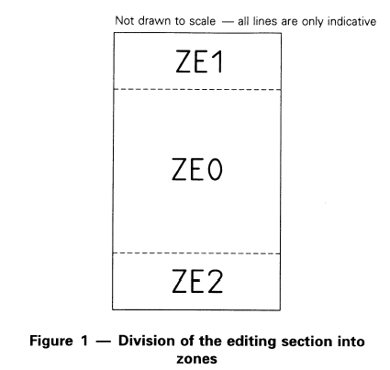

Zone ZEO is the cursor zone of the editing section. The arrangement, the number, and the location of the keys as well as the allocation of functions to the keys are specified in clauses 7 to 9 of this part of lSO/IEC 9995.
The zones ZEI and ZE2 are the editing zones of the editing section. The arrangement, the number, and the location of the keys as well as the allocation of functions to the keys are specified in clause 10 of this part of lSO/IEC 9995.

7 Cursor zone arrangement and location The area of the cursor zone ZEO is shown in figure2.
The keys of the cursor zone ZEO shall be arranged in one of two ways: The “cross” arrangement (see 7.1) or the “inverted T” arrangement (see 7.2). This part of lSO/IEC 9995 does not indicate a preference for a particular arrangement.
71 . “Cross” arrangement
The “cross” arrangement is shown in figure3 as located in rows A, B and C in the cursor zone ZEO. It may alternatively be located in the same columns of rows B, C and D in the same zone. The placement of the “cross” arrangement may be influenced by the size and placement of the editing zones ZEI and ZE2.
72 . “Inverted T” arrangement
The “inverted T” arrangement is shown in figure4 as located in rows A and B. It may alternatively be located in the same columns of rows B and C or in the same columns of rows C and D. The placement of the “inverted T” arrangement may be influenced by the size and placement of the editing zones ZEI and ZE2.
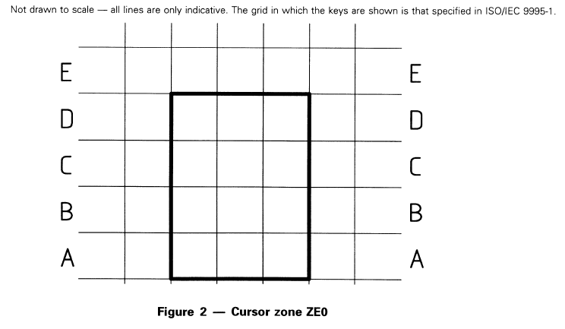

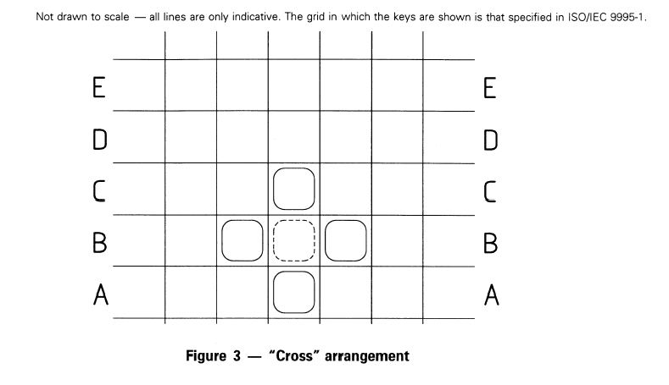

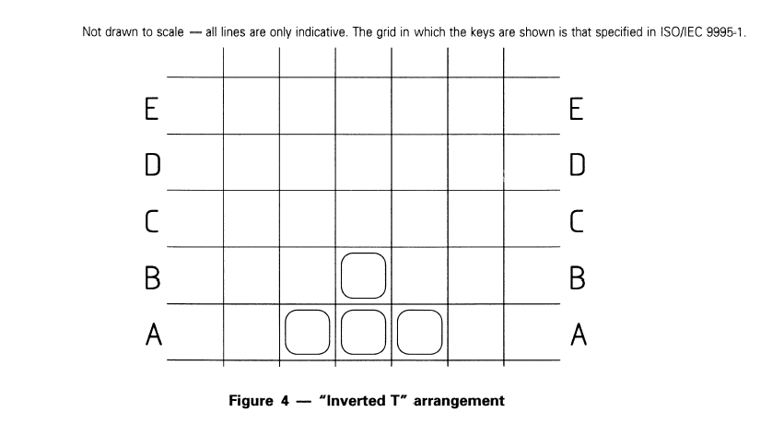

8 Functions of the cursor zone
The four basic cursor control functions to be allocated to the keys of the cursor zone are: Cursor up, Cursor down, Cursor left, Cursor right.
The use of symbols for cursor function keys shall be as specified in lSO/IEC 9995-7.
9 Allocation
The four basic cursor control functions shall be allocated to the keys of the cursor zone ZEO in one of two ways selected from clause 9, to give either the “cross” layout (see 9.1) or the “inverted T” layout (see 9.2).
91 . “Cross” layout
The use of symbols for cursor function keys shall be as specified in lSO/IEC 9995-7.
The keys are marked with the symbols of table I according to the principles of key labelling as specified in lSO/lEC 9995-l.
The “cross” layout is shown in figure5 as located in rows A, B, and C in the cursor zone ZEO. It may alternatively be located in rows B, C, and D of the same zone. The placement of the “cross” layout may be influenced by the size and placement of the editing zones ZEI and ZE2.
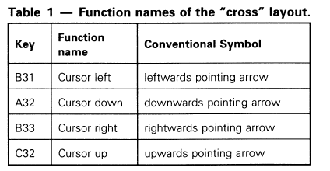

This part of this International Standard does not define any function to be allocated to the key in the middle of the “cross” layout. It is permitted to use the key for a function for cursor manipulation or not to provide this key at all. In the latter case, the keys for horizontal movement of the cursor may be placed immediately adjacent to each other so that the cross arrangement is only two columns wide. The preferred method is the three-column wide cross shown in figure 5.

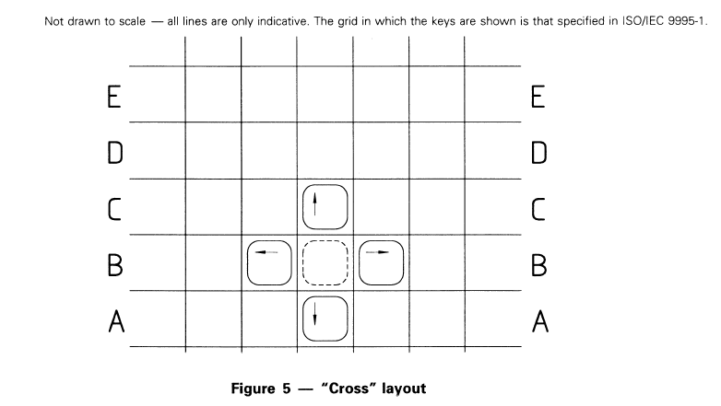

9.2 . “Inverted T” layout
The use of symbols for cursor function keys shall be as specified in ISO/IEC 9995-7.
The keys are marked with the symbols of table2 according to the principles of key labelling as specified in lSO/lEC 9995-l.
The “inverted T” layout is shown in figure6 as located in rows A and B in the cursor zone ZEO. It may alternatively be located in rows B and C or in rows C and D of the same zone. The placement of the “inverted T” layout may be influenced by the size and placement of the editing zones ZEI and ZE2.
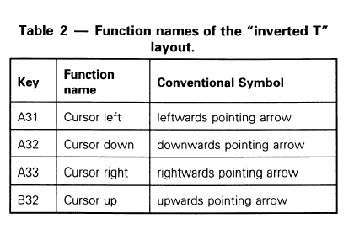
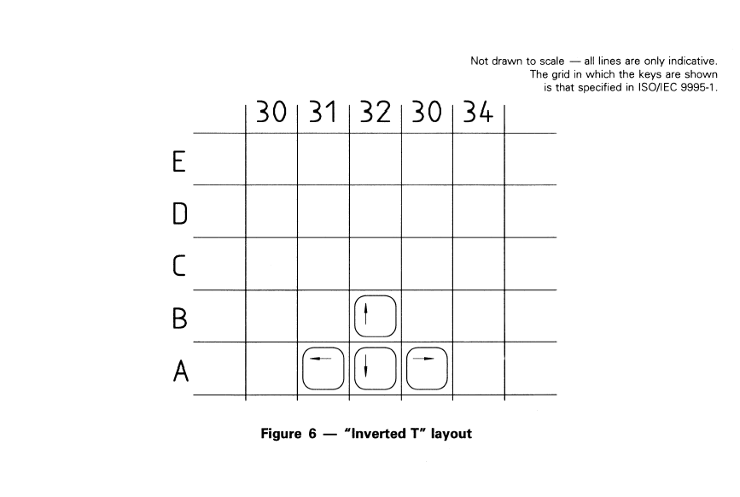

10 Arrangement and location of the editing zone
There will usually be only one editing zone, either ZEI or ZE2 (figures 7 and 8). The arrangement and location of these zones is dependent on the location and arrangement of the cursor zone ZEO. The border between ZEO and ZEI, and the border between ZEO and ZE2 is not fixed (figure I).
10.1 Editing zone ZEI
The keys shall be arranged in the editing zone ZEI and be located as illustrated in figure 7.
The editing zone ZEI shall occupy row E. It may use row D, and may extend into row C. The size of the editing zone ZEI may be influenced by the size and placement of the cursor zone ZEO.
10.2 Editing zone ZE2
The keys shall be arranged in the editing zone ZE2 and be located as illustrated in figure 8.
The editing zone ZE2, if present, shall occupy row A. It may extend into row B. The size of the editing zone ZE2 may be influenced by the size and placement of the cursor zone ZEO.

11 Functions of the editing zone
The editing functions for example allocated to the keys of the editing zone include: Delete, Insert, Next Page, Previous Page.
12 Allocation guidelines
The basic editing functions for example are Delete, Insert, Next Page, Previous Page. These functions, if implemented shall be allocated to level 1 of the respective key.
When allocating the functions to the keys of the editing zone it is important to pay attention to logical, functional and ergonomic aspects.
If symbols are used for the identification of the editing functions implemented on a keyboard they shall be as specified in lSO/IEC 9995-7.
